ARYAMAN MISHRA

19BCE1027

Dr.B.Saleena

1) #include<stdio.h>

struct player

{

int pid;

float avgrun,avgwick;

char name[30];

};

int i,j;

void input(struct player s[10],int n)

{

for(i=0;i<n;i++)

{

printf("Enter the details of player %d\n",i+1);

printf("Enter the player id: ");

scanf("%d",&s[i].pid);

printf("Enter the name: ");

scanf("%s",&s[i].name);

printf("Enter the average runs: ");

scanf("%f",&s[i].avgrun);

printf("Enter the average wickets: ");

scanf("%f",&s[i].avgwick);

}

}

void sort(struct player p[10],int n)

{

for(i=0;i<n-1;i++)

{

for(j=0;j<n-1;j++)

if(p[j].avgrun < p[j+1].avgrun)

{

struct player temp = p[j];

p[j] = p[j+1];

p[j+1] = temp;

}

}

}

void display(struct player s[10],int n)

{

printf("Sorted List:\n");

for(i=0;i<n;i++)

{

printf("\nPlayer id: %d",s[i].pid);

printf("\nPlayer Name: %s",s[i].name);

printf("\nAverage Runs: %f",s[i].avgrun);

printf("\nAverage Wickets: %f\n",s[i].avgwick);

}

}

int main()

{

int n;

struct player p[10];

printf("Enter the number of records to be entered: ");

scanf("%d",&n);

input(p,n);

sort(p,n);

display(p,n);

return 0;

}

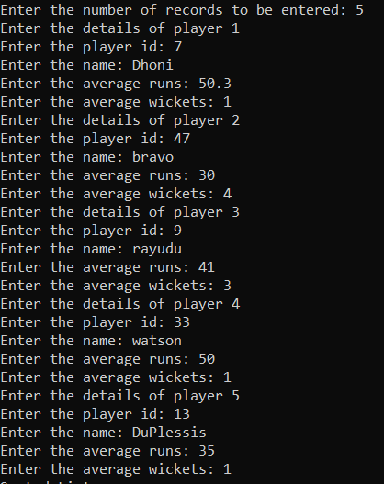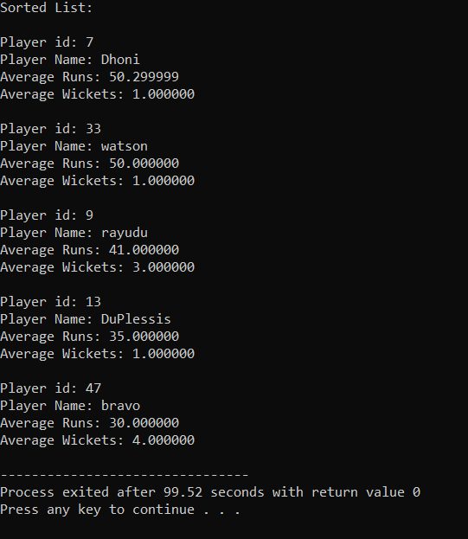

2) #include <stdio.h>

#include <stdlib.h>

void push(char element, char stack[], int \*top, int StackSize){

if(\*top == -1)

{

stack[StackSize - 1] = element;

\*top = StackSize - 1;

}

else if(\*top == 0)

{

printf("The stack is already full. \n");

}

else

{

stack[(\*top) - 1] = element;

(\*top)--;

}

}

void pop(char stack[], int \*top, int StackSize)

{

if(\*top == -1)

{

printf("The stack is empty. \n");

}

else

{

printf("Element popped: %c \n", stack[(\*top)]);

if((\*top) == StackSize - 1)

{

(\*top) = -1;

}

else{

(\*top)++;

}

}

}

void display(char stack[], int \*top, int StackSize)

{

int i;

printf("\nStack is...\n");

for(i=10;i>=0;--i)

printf("%c\n",stack[i]);

}

int main()

{

int StackSize=10;

char Stack[StackSize];

int count=0,top=-1,choice=1;

char ch;

while(choice==1)

{

printf("\nStack Menu");

printf("\n\n1.Push\n2.Pop\n3.Display");

printf("\n\nEnter your choice(1-4):");

scanf("%d",&ch);

if(ch==1)

count++;

if(count==4)

{

printf("Level 4 reached.Reorder Rice Stack.");

exit(0);

}

switch(ch)

{

case 1: push('R',Stack,&top,StackSize);

break;

case 2: pop(Stack,&top,StackSize);

break;

case 3: display(Stack,&top,StackSize);

break;

default: printf("\nWrong Choice!!");

}

printf("Enter 1 to Put or remove Rice Stack or 0 to End\n");

scanf("%d",&choice);

}

}

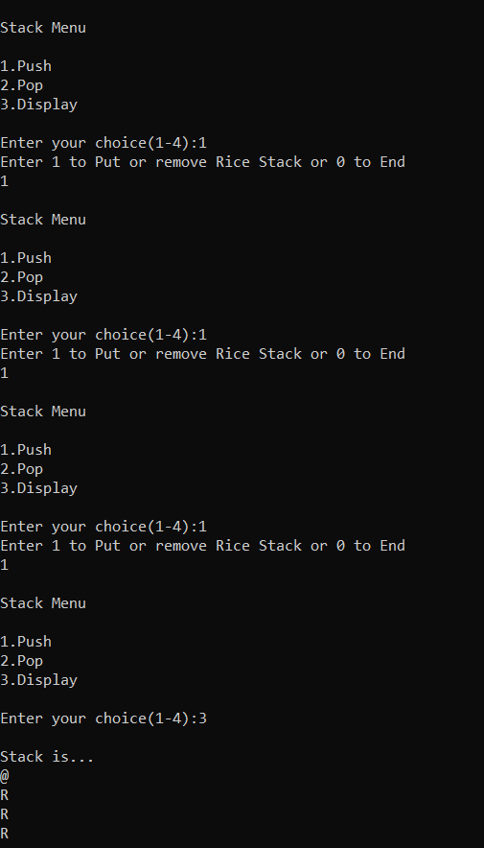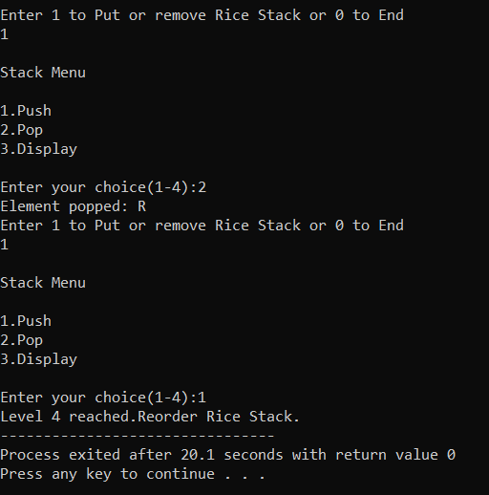

3)

#include <stdio.h>

void push(char element, char stack[], int \*top, int stackSize){

if(\*top == -1)

{

stack[stackSize - 1] = element;

\*top = stackSize - 1;

}

else if(\*top == 0)

{

printf("The stack is already full. \n");

}

else

{

stack[(\*top) - 1] = element;

(\*top)--;

}

}

void pop(char stack[], int \*top, int stackSize)

{

if(\*top == -1)

{

printf("The stack is empty. \n");

}

else

{

printf("Element popped: %c \n", stack[(\*top)]);

if((\*top) == stackSize - 1)

{

(\*top) = -1;

}

else{

(\*top)++;

}

}

}

int main()

{

int n;

char stack[20];

int top = -1;

printf("Enter expression\n");

char str[20],x;

gets(str);

for (int i = 0; i < sizeof(str); i++)

{

x=str[i];

if(x=='(')

{

push(x, stack, &top, 20);

}

else

{

if(x==')')

{

pop(stack, &top, 20);

}

}

if(x=='$')

{

if(top==-1)

{

printf("Balanced");

}

else

{

printf("Unbalanced");

}

}

}

return 0;

}

